ML task 1 – 211314570 208300244
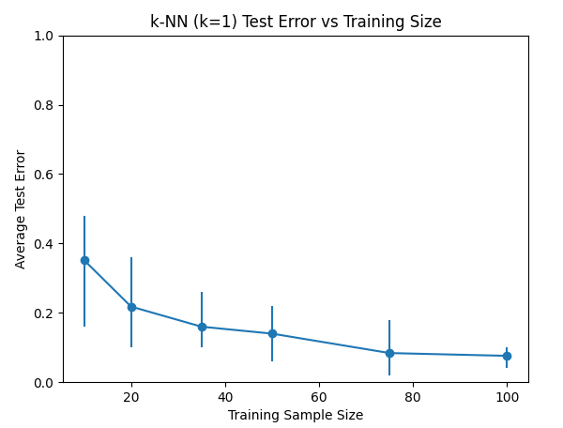
a)

b) For k-NN, the graph shows that increasing the training sample size lowers the average test error. This happens because with more training data, the nearest neighbors for each test point are closer and more representative of the true class, so k-NN makes fewer mistakes. With a small training set, the nearest neighbor may be far away or mislabeled, leading to higher error.
c) Yes, the error bars get smaller as the training sample size increases.
This means the variability in test error decreases with larger training sets.
The reason is that with more training data, k-NN predictions become more stable and less sensitive to which random samples are chosen, so the error is more consistent across runs.

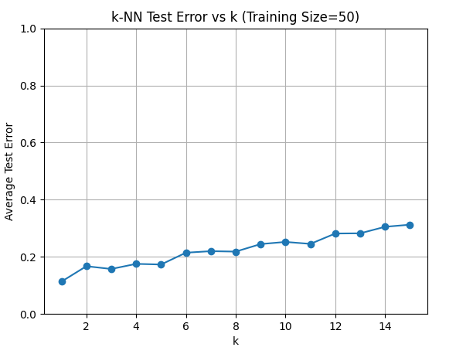
d)

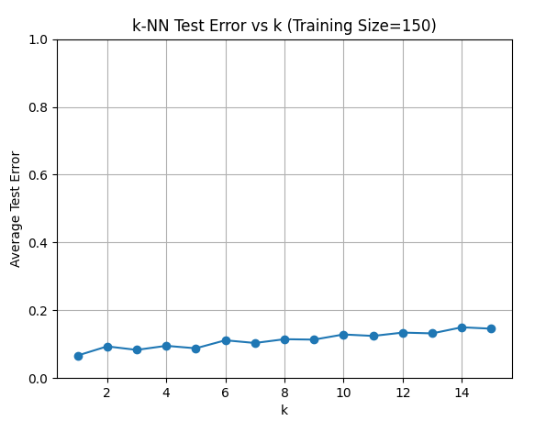

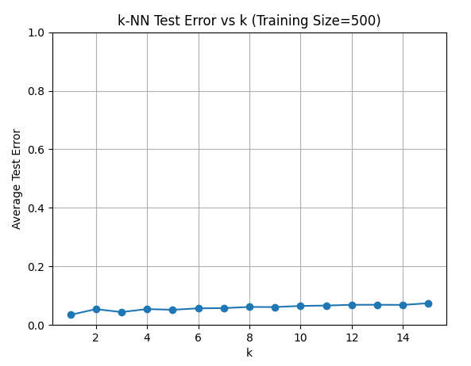

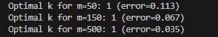

e)
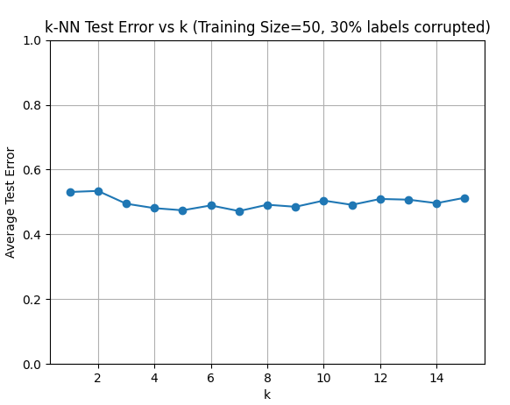
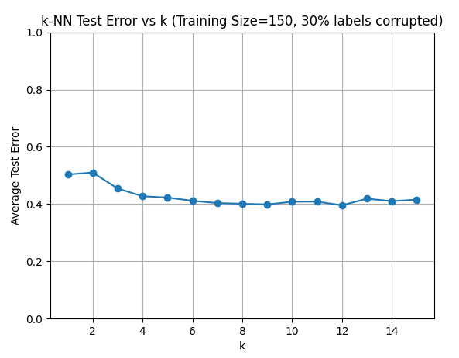

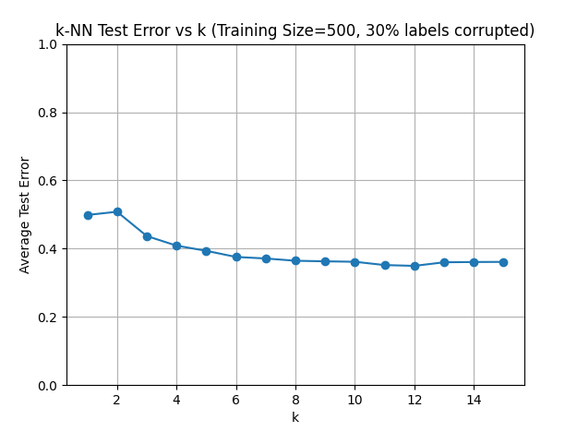

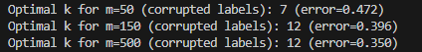

f) With corrupted labels, using a larger $k$ helps average out the noise from incorrect labels, making the classifier more robust. In the clean data experiment, a small $k$ is best because the labels are reliable.
In summary, label corruption increases the optimal $k$ and the overall error, because higher $k$ reduces the impact of noisy labels by majority voting.

Q3:
- X should be the age and weight [age, weight] of the rabbit and Y should be the preferred food
- hbayes(7,1) = lettuce
hbayes(7,2) = lettuce
hbayes(13,1) = carrot
hbayes(13,2) = lettuce
because the distribution is deterministic the err(hbayes) is 0. err(hbayes) =0

Age | Preferred food | probability
7 | Lettuce | 60%
7 | carrot | 0%
13 | Lettuce | 25%
13 | Carrot | 15%

hbayes(7) = lettuce
hbayes(13) = lettuce

err(hbayes) = P[X = 7] * P[h(x)!=lettuce|X=7] + P[X = 13] * P[h(x)!=lettuce|X=13]
err(hbayes) = 0.6 * 0 + 0.4 * (15/40) = 0.15

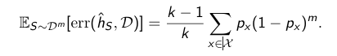

k=2
m=2
px = the probability to draw x from the distribution
D = the distribution given in the table
Es~Dm[err(hs,D)] = 0.10*(1 - 0.10)^2 + 0.50*(1 - 0.50)^2 + 0.15*(1 - 0.15)^2 +
0.25*(1 - 0.25)^2 = 0.455

Q4:
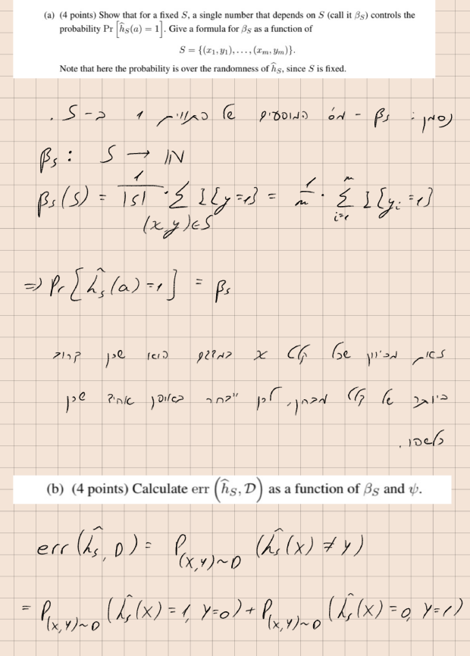

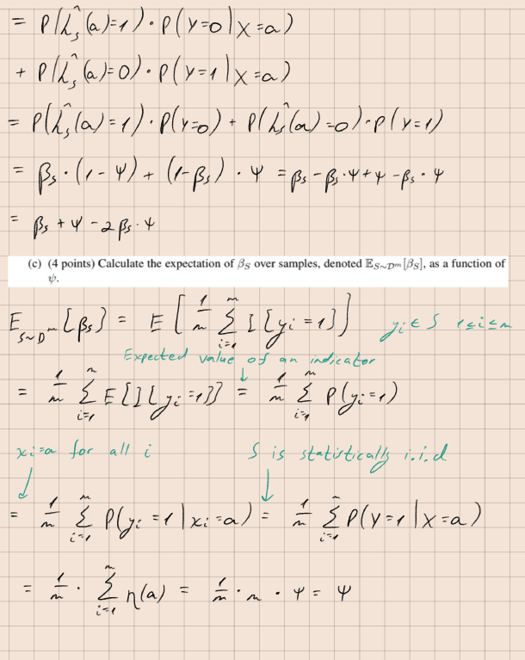

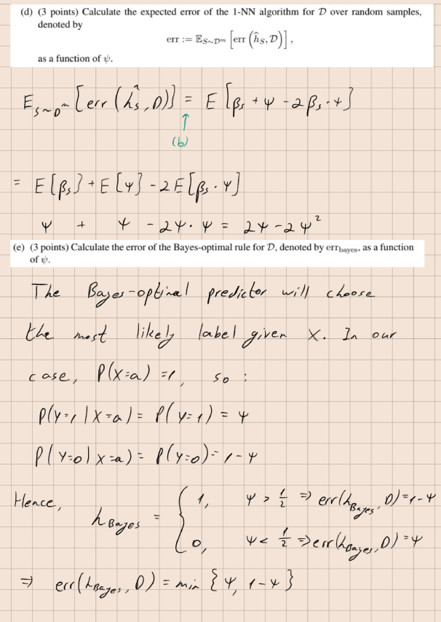
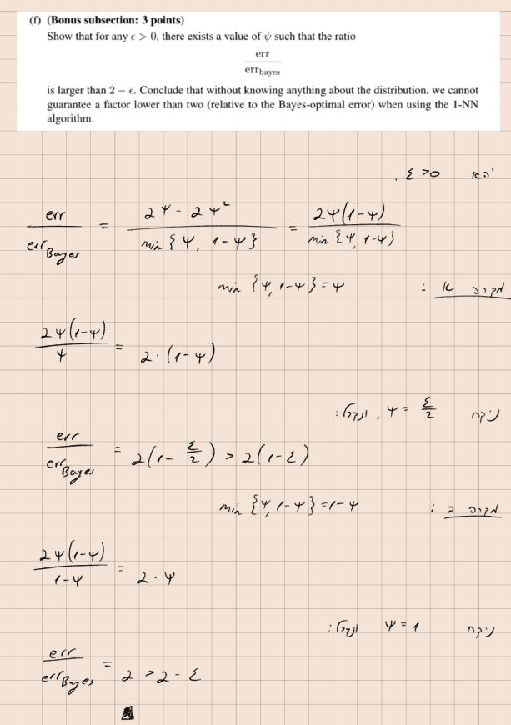

Q5:
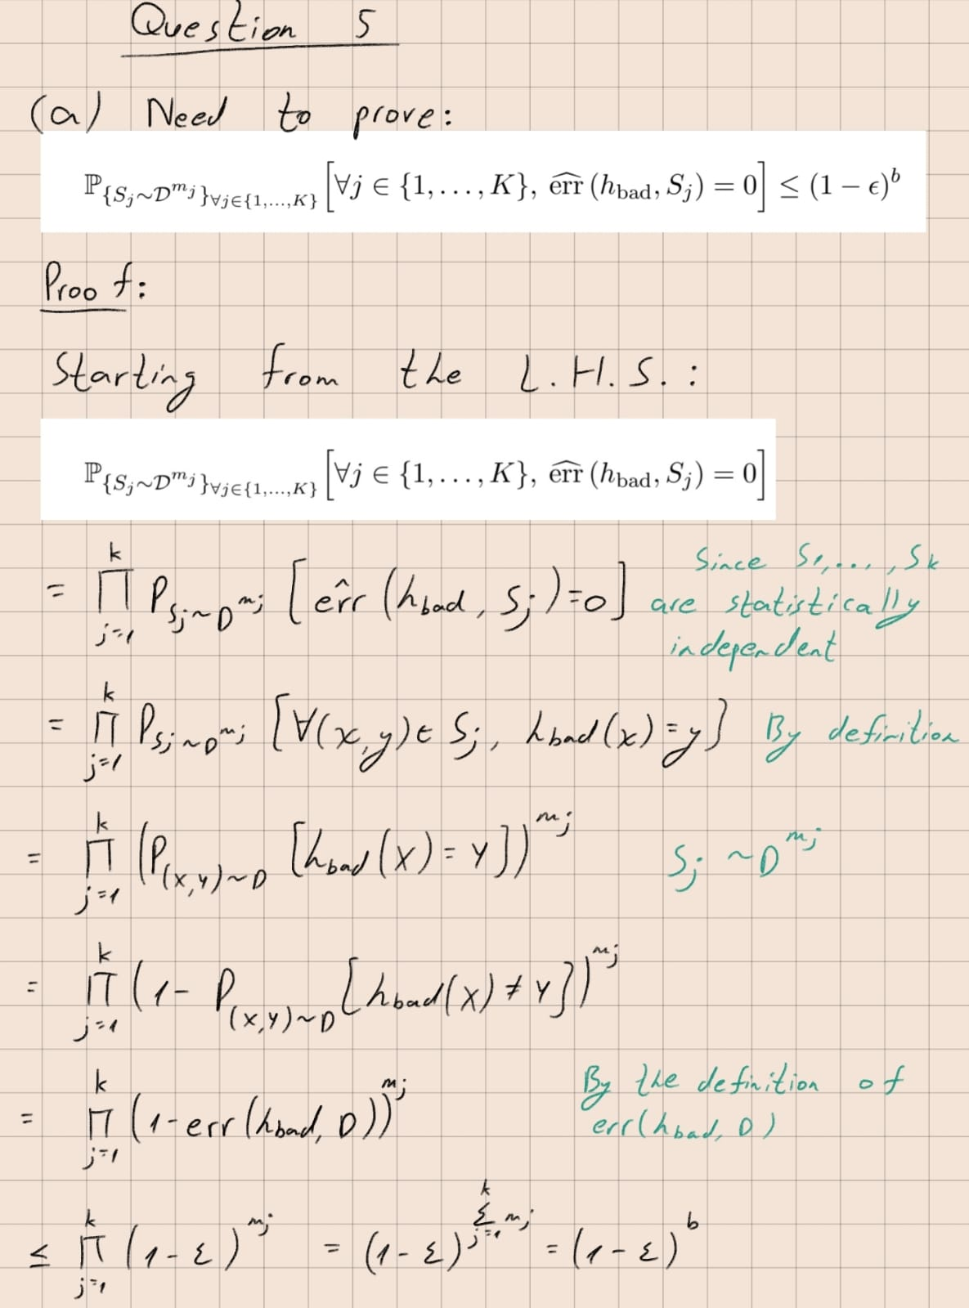

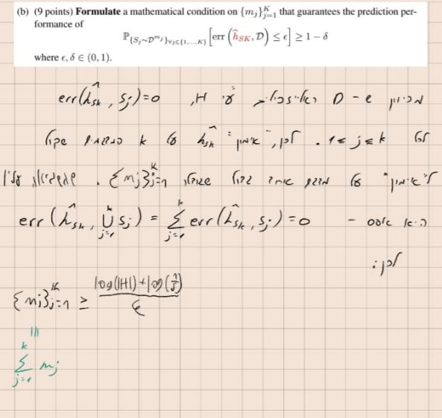

Q6:
